Big Mountain Resort hopes to cut costs or drive revenue, but ultimately we can conclude that driving revenue is the way to go. Of the parameters given in the dataset, we identified through a linear regression model the strongest determining coefficients of Big Mountain’s popularity:

* Vertical Drop
* Snow Making
* # of Chairs
* # of Runs
* Longest Run
* Trams
* Skiable Terrain

Correlation of summit elevation and other highlighted variables can be viewed below as part of our study:

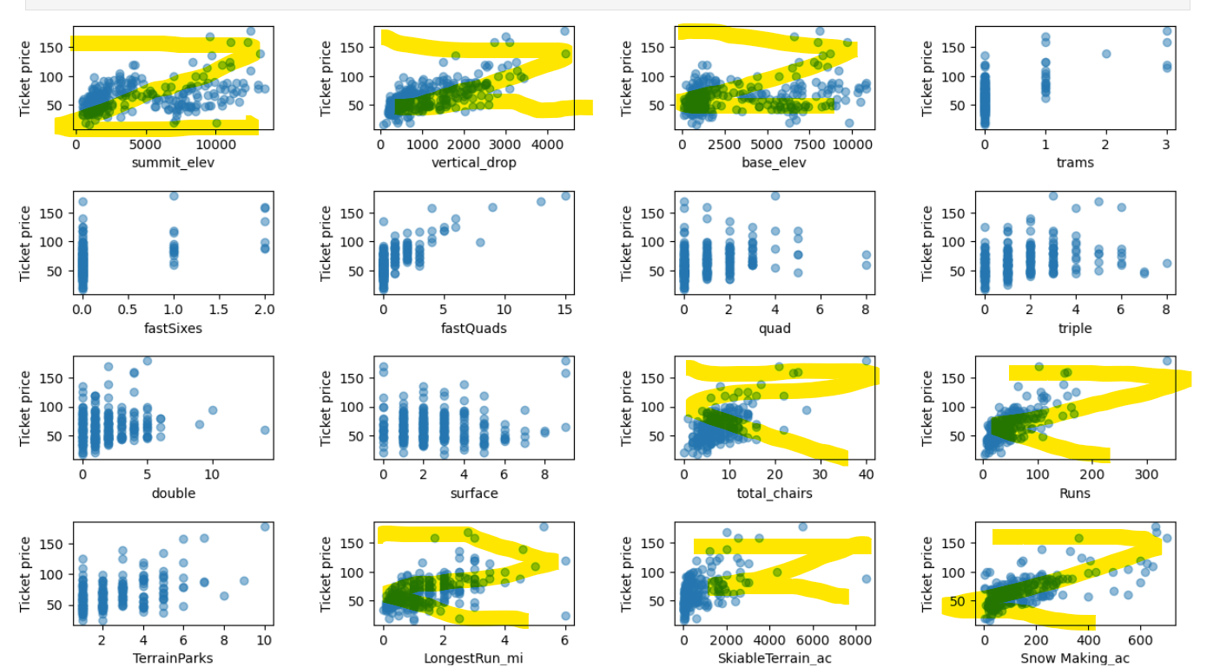

Ski resort ticket prices seem to rise with factors offering a more extensive and enjoyable experience. Higher mountain features like summit elevation and vertical drop, along with increased amenities like chairlifts and runs, correlate with higher prices. Additionally, locations with longer winter seasons and colder climates, often reflected in higher base and summit elevations, typically offer more snowfall and command higher ticket prices compared to warmer regions.

We proceeded to feed the data into a random forest regression model. Gauging against Big Mountain’s current standing in the competition, we uncovered:

1. Big Mountain rests on the upper end of ticket pricing.
2. Big Mountain also acts as one of the highest vertical drops of all ski resorts and largest in snow making area.
3. Big Mountain has one of the largest number of chairs, number of runs, and significantly more fast quads than the average resort.
4. Big Mountain has among the most skiable terrain.

Running through the given scenarios in our model, we found two particular cases where revenue showed significant change if implemented.

1. Removing more than 1 poor performing run can significantly decrease revenue and ticket pricing.

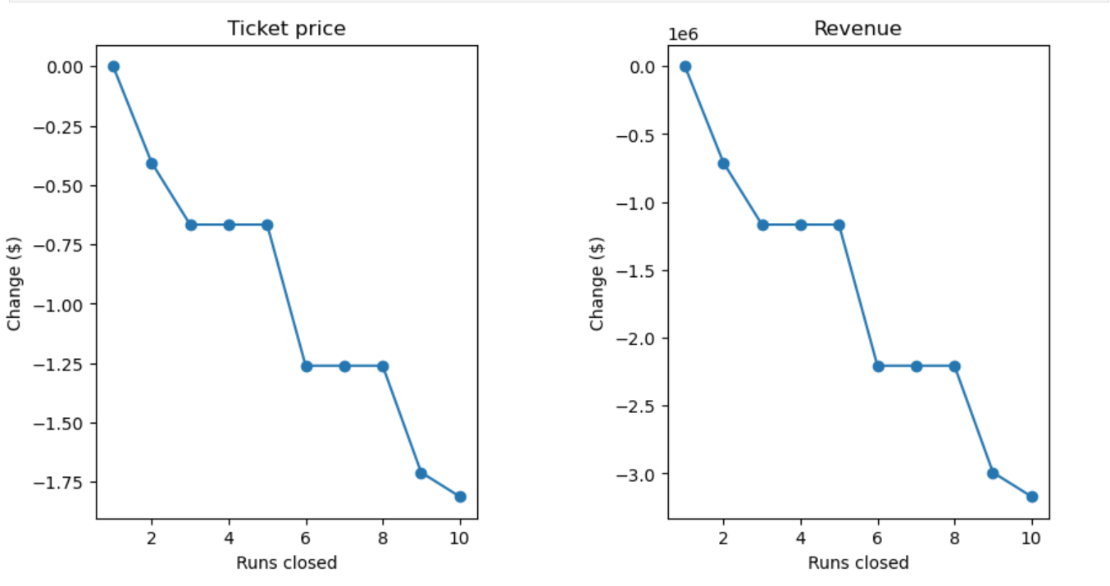

1. Adding a run with a vertical drop of 150 feet while installing a chair lift can increase ticket price support by $1.99 and amount to $3,474,638 increase in revenue.

Big Mountain, despite being a pricier resort than both national and Montana averages, may be justified in raising its ticket price based on its superior offerings. Compared to the average resort, Big Mountain boasts higher elevation, more snow-making capabilities, more chairs and fast quads, and more skiable terrain. While closing a run likely won't impact revenue, adding a new run with a 150-foot vertical drop holds promise for a significant rise in both ticket price and revenue. Overall, further exploration of both scenarios 1 and 2 (close the least performing run and adding a 150 run) is recommended, with cost analysis being a crucial next step.